NAME- Vibhum Bhattad
PRN NO- 202501050037

PRACTICAL NO.4

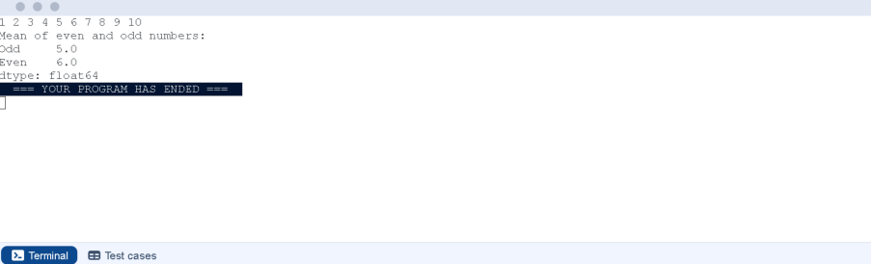

A dictionary of lists has been provided to you in the editor. Create a DataFrame
from the dictionary of lists and perform the listed operations, then display the
DataFrame before and after each manipulation.
Create the DataFrame:
• Convert the dictionary to a Pandas DataFrame.
Add a new row:
• Take inputs from the user for the new row data (name, age).
• Add the new row to the DataFrame.
• Display the DataFrame after adding the new row.
Modify a row:
• Modify a specific row by changing the age. Take the row index and new
age value from the user.
• Display the DataFrame after modifying the row.
Delete a row:
• Take the row index to be deleted from the user.
• Remove the specified row.
• Display the DataFrame after deleting the row.
Add a new column:
• Add a column Gender with values taken from the user.
• Display the DataFrame after adding the new column.
Modify a column:

• Convert names to uppercase.
• Display the DataFrame after modifying the column.
Delete a column:
• Remove the Age column.
• Display the DataFrame after deleting the column.
CODE:
import pandas as pd
# Provided dictionary of lists
data = {
'Name': ['Alice', 'Bob', 'Charlie'],
'Age': [25, 30, 35],
}
# Convert the dictionary to a DataFrame
df = pd.DataFrame(data)
# Display the original DataFrame
print("Original DataFrame:")
print(df)
# Adding a new row
new_name = input("New name: ")
new_age = int(input("New age: "))
new_row = {'Name': new_name, 'Age': new_age }

df = df.append(new_row,ignore_index = True)
# Display the DataFrame after adding a new row
print("After adding a row:\n",df)
# Modifying a row
row_to_modify = int(input("Index of row to modify: "))
new_age_value = int(input("New age: "))
df.at[row_to_modify, "Age"] = new_age_value
# Display the DataFrame after modifying a row
print("After modifying a row:")
print(df)
row_to_delete = int(input("Index of row to delete: "))
df = df.drop(index=row_to_delete).reset_index(drop=True)
# Deleting a row
# Display the DataFrame after deleting a row
print("After deleting a row:")
print(df)
# Adding a new column
genders = input("Enter genders separated by space: ").split()
df["Gender"] = genders
# Display the DataFrame after adding a new column
print("After adding a new column:")
print(df)

# Modifying a column
df['Name'] = df['Name'].str.upper()
# Display the DataFrame after modifying a column
print("After modifying a column:")
print(df)
# Deleting a column
df = df.drop(columns ='Age').reset_index(drop=True)
# Display the DataFrame after deleting a column
print("After deleting a column:")
print(df)
OUTPUT:

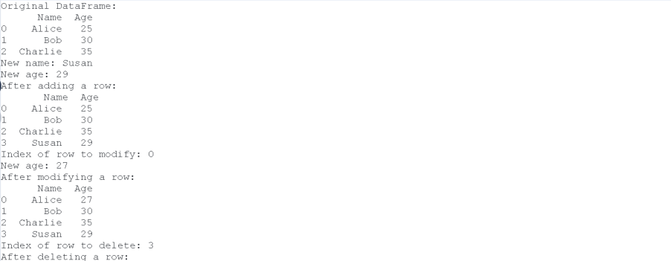
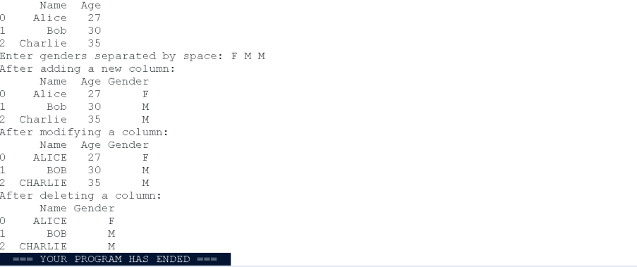

Write a program to read a text file containing student information (name, age,
and grade) using Pandas. Perform the following tasks:
• Display the first five rows of the data frame.
• Calculate the average age of the students (limit the average age up to 2
decimal places).
• Filter out the students who have a grade above a certain threshold
(consider the threshold grade is 'B').
Note:
Refer to the displayed test cases for better understanding.
CODE:
import pandas as pd
# Read the text file into a DataFrame
file = input()
data = pd.read_csv(file, sep="\s+", header=None, names=["Name", "Age",
"Grade"])
# write your code here..
print("First five rows:")
print(data.head())
average_age= round(data["Age"].mean(), 2)
print(f"Average age: {average_age}")

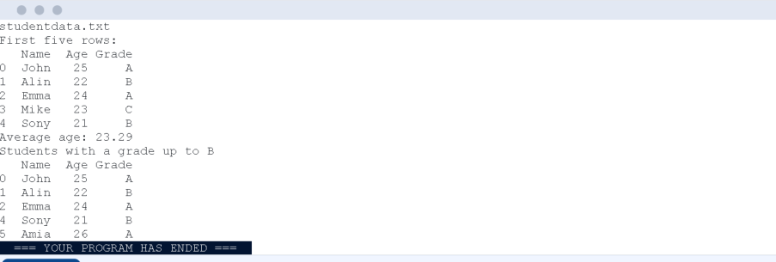

filtered_student = data[data["Grade"] <= "B"]
print("Students with a grade up to B")
print(filtered_student)
OUTPUT:

Write a Python program that takes the file name of a CSV file as input, reads
the data, and performs the following operations:
• The CSV file contains the columns: Date, Product, Quantity, Price, and
City.
• Group the data by Month and calculate the total sales for each month.
• Find the month with the highest total sales and display it.
• Also, display the total sales for the best month.
CODE:
import pandas as pd
# Prompt the user for the file name
file_name = input()
# Load the data
df = pd.read_csv(file_name)
df["Date"] = pd.to_datetime(df["Date"])
df["Month"] = df["Date"].dt.to_period("M")
df["Total Sales"] = df["Quantity"] * df["Price"]
monthly_sales = df.groupby("Month")["Total Sales"].sum()
best_month = monthly_sales.idxmax()
highest_sales = monthly_sales.max()

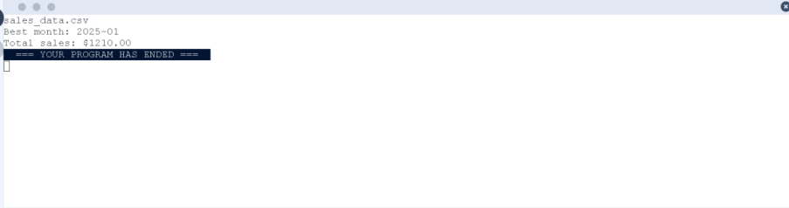

print(f"Best month: {best_month}")
print(f"Total sales: ${highest_sales:.2f}")
OUTPUT:

Write a Python program that takes the file name of a CSV file as input, reads
the data, and performs the following operations:
• The CSV file contains the columns: Date, Product, Quantity, Price, and
City.
• Find the product that sold the most in terms of quantity sold.
• Display the product that sold the most and the total quantity sold for
that product.
CODE:
import pandas as pd
# Prompt the user for the file name
file_name = input()
# Load the data
df = pd.read_csv(file_name)
product_sales = df.groupby("Product")["Quantity"].sum()
best_product = product_sales.idxmax()
highest_quantity = product_sales.max()
# Display the result
print(f"Best selling product: {best_product}")
print(f"Total quantity sold: {highest_quantity}")

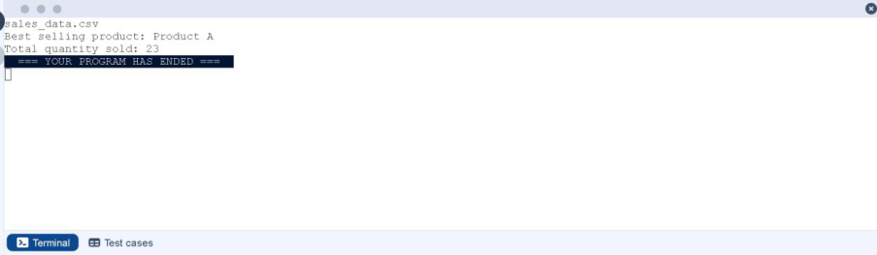

OUTPUT:

Write a Python program that takes the file name of a CSV file as input, reads
the data, and performs the following operations:
• The CSV file contains the columns: Date, Product, Quantity, Price, and
City.
• Group the data by City and calculate the total quantity of products sold
for each city.
• Find the city that sold the most products (based on the total quantity
sold).
CODE:
import pandas as pd
# Prompt the user for the file name
file_name = input()
# Load the data
df = pd.read_csv(file_name)
# write the code..
city_sales = df.groupby("City")["Quantity"].sum()
best_city = city_sales.idxmax()
# Display the result
print(f"City sold the most products: {best_city}")

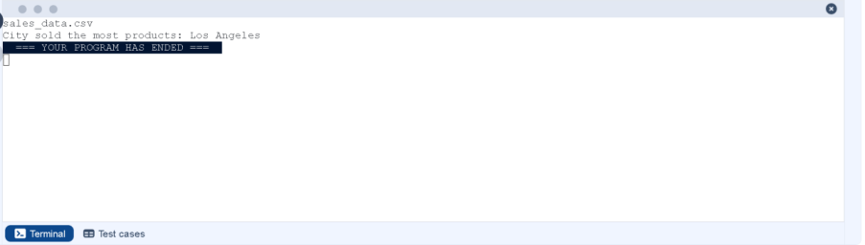

OUTPUT:

Write a Python program that takes the file name of a CSV file as input, reads
the data, and performs the following operations:
• The CSV file contains the following columns: Date, Product, Quantity,
Price, and City.
• For each date, find all pairs of products that were sold together (i.e., two
products sold on the same date).
• Output the product pair/s that was sold most frequently.
CODE:
import pandas as pd
from itertools import combinations
from collections import Counter
# Prompt user to input the file name
file_name = input()
# Read data from the specified CSV file
df = pd.read_csv(file_name)
# write the code
grouped = df.groupby("Date")["Product"].apply(list)
# Output the most frequent product pairs
pairs_counter = Counter()
for products in grouped:
pairs = combinations(sorted(products), 2)
pairs_counter.update(pairs)

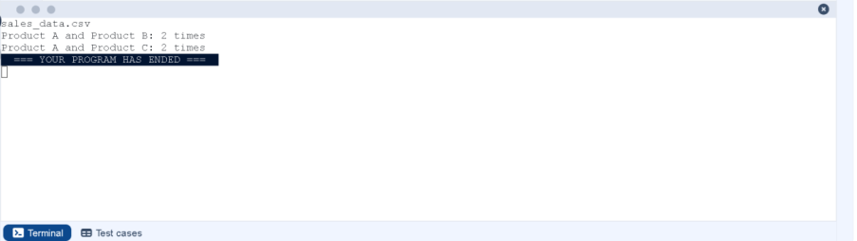

max_frequency = max(pairs_counter.values())
most_common_pairs = [(pair, freq) for pair, freq in pairs_counter.items() if freq
== max_frequency]
for (product1,product2),frequency in most_common_pairs:
print(f"{product1} and {product2}: {frequency} times")
OUTPUT:

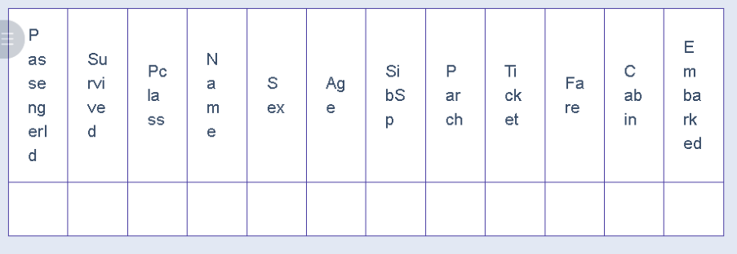

You are provided with the Titanic dataset containing information about
passengers on the Titanic. Your task is to write Python code to answer the
following questions based on the dataset. For each question, perform
necessary data cleaning, transformations, and calculations as required.
1. Display the first 5 rows of the dataset.
2. Display the last 5 rows of the dataset.
3. Get the shape of the dataset (number of rows and columns).
4. Get a summary of the dataset (using .info()).
5. Get basic statistics (mean, standard deviation, etc.) of the dataset using
.describe().
6. Check for missing values and display the count of missing values for each
column.
7. Fill missing values in the ‘Age’ column with the median age.
8. Fill missing values in the ‘Embarked’ column with the most frequent
value (mode()).
9. Drop the ‘Cabin’ column due to many missing values.
10.Create a new column, 'FamilySize' by adding the 'SibSp' and 'Parch'
columns.
The Titanic dataset contains columns as shown below,

CODE:
import pandas as pd
import numpy as np
# Load the Titanic dataset
data = pd.read_csv('Titanic-Dataset.csv')
# 1. Display the first 5 rows of the dataset
print(data.head())
# 2. Display the last 5 rows of the dataset
print(data.tail())
# 3. Get the shape of the dataset
print(data.shape)
# 4. Get a summary of the dataset (info)
print(data.info())
# 5. Get basic statistics of the dataset
print(data.describe())
# 6. Check for missing values
print(data.isnull().sum())
# 7. Fill missing values in the ‘Age’ column with the median age

median_age = data["Age"].median()
data["Age"].fillna(median_age,inplace=True)
# 8. Fill missing values in the ‘Embarked’ column with the mode
mode_embarked = data['Embarked'].mode() [0]
data['Embarked'].fillna(mode_embarked, inplace=True)
# 9. Drop the ‘Cabin’ column due to many missing values
data.drop('Cabin', axis=1, inplace=True)
# 10. Create a new column 'FamilySize’ by adding ‘SibSp' and ‘Parch'
data['FamilySize'] = data['SibSp'] + data['Parch']
OUTPUT:

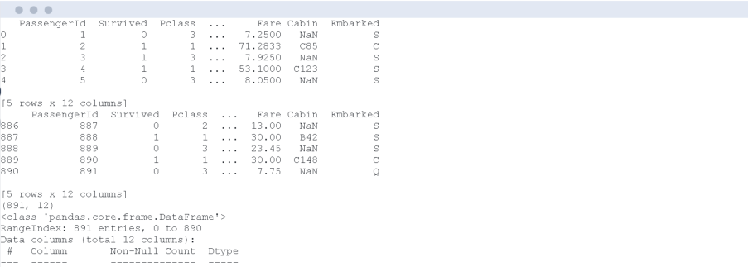
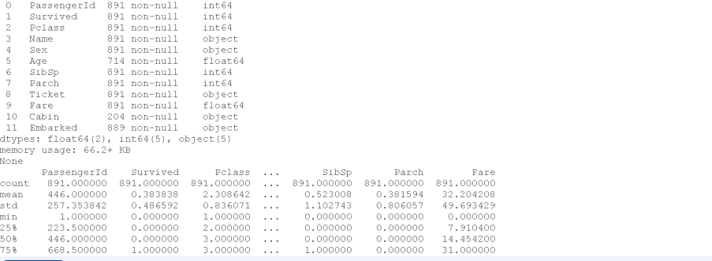
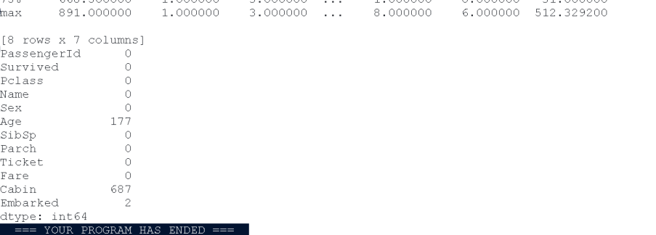

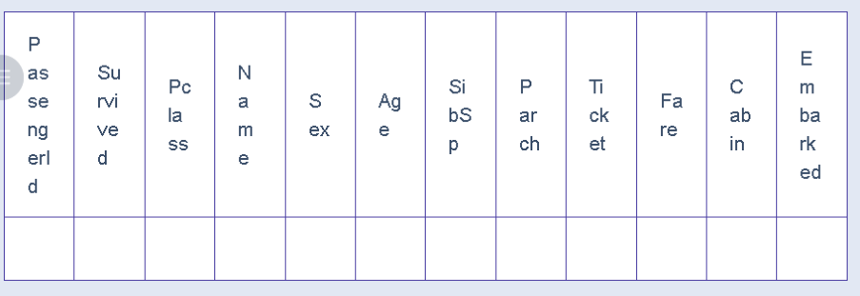

You are provided with the Titanic dataset containing information about
passengers on the Titanic. Your task is to write Python code to answer the
following questions based on the dataset.
1. Create a new column ‘IsAlone’ which is 1 if the passenger is alone
(FamilySize = 0), otherwise 0.
2. Convert the ‘Sex' column to numeric values (male: 0, female: 1).
3. One-hot encode the ‘Embarked’ column, dropping the first category.
4. Get the mean age of passengers.
5. Get the median fare of passengers.
6. Get the number of passengers by class.
7. Get the number of passengers by gender.
8. Get the number of passengers by survival status.
9. Calculate the survival rate of passengers.
10.Calculate the survival rate by gender.
The Titanic dataset contains columns as shown below
CODE:
# Load the Titanic dataset
data = pd.read_csv('Titanic-Dataset.csv')
data['FamilySize'] = data['SibSp'] + data['Parch']
# 1. Create a new column ‘IsAlone' (1 if alone, 0 otherwise)

data['IsAlone'] = np.where(data['FamilySize'] == 0, 1, 0)
# 2. Convert ‘Sex' to numeric (male: 0, female: 1)
data['Sex'] = data['Sex'].map({'male': 0, 'female': 1})
# 3. One-hot encode the ‘Embarked' column
data = pd.get_dummies(data, columns=['Embarked'])
# 4. Get the mean age of passengers
mean_age = data['Age'].mean()
print( mean_age)
# 5. Get the median fare of passengers
median_fare = data['Fare'].median()
print( median_fare)
# 6. Get the number of passengers by class
print( data['Pclass'].value_counts())
# 7. Get the number of passengers by gender
print( data['Sex'].value_counts())
# 8. Get the number of passengers by survival status
print( data['Survived'].value_counts())
# 9. Calculate the overall survival rate

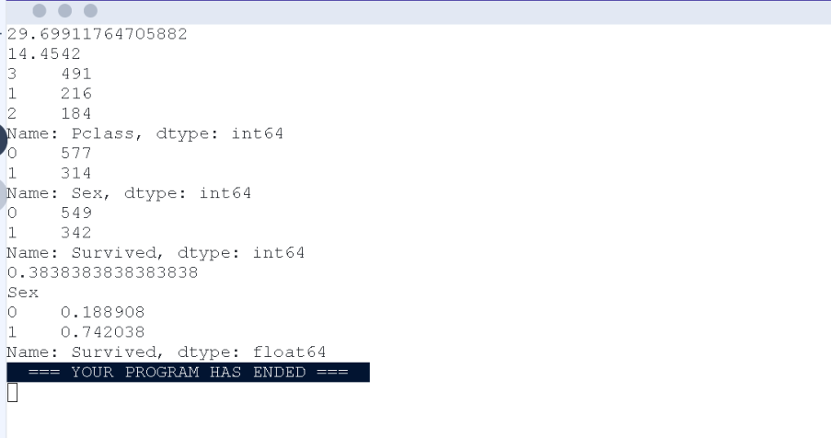

survival_rate = data['Survived'].mean()
print(format(survival_rate))
# 10. Calculate the survival rate by gender
survival_by_gender = data.groupby('Sex')['Survived'].mean()
print( survival_by_gender)
OUTPUT:

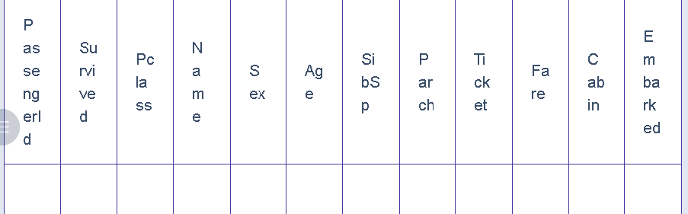

You are provided with the Titanic dataset containing information about
passengers on the Titanic. Your task is to write Python code to answer the
following questions based on the dataset.
1. Calculate the survival rate by class.
2. Calculate the survival rate by embarkation location (Embarked_S).
3. Calculate the survival rate by family size (FamilySize).
4. Calculate the survival rate by being alone (IsAlone).
5. Get the average fare by passenger class (Pclass).
6. Get the average age by passenger class (Pclass).
7. Get the average age by survival status (Survived).
8. Get the average fare by survival status (Survived).
9. Get the number of survivors by class (Pclass).
10.Get the number of non-survivors by class (Pclass).
The Titanic dataset contains columns as shown below,
CODE:
import pandas as pd

import numpy as np
# Load the Titanic dataset
data = pd.read_csv('Titanic-Dataset.csv')
data['FamilySize'] = data['SibSp'] + data['Parch']
data['IsAlone'] = np.where(data['FamilySize'] > 0, 0, 1)
data = pd.get_dummies(data, columns=['Embarked'], drop_first=True)
# 1. Calculate the survival rate by class
print(data.groupby('Pclass')['Survived'].mean())
# 2. Calculate the survival rate by embarked location
print(data.groupby('Embarked_S')['Survived'].mean())
# 3. Calculate the survival rate by family size
print(data.groupby('FamilySize')['Survived'].mean())
# 4. Calculate the survival rate by being alone
print(data.groupby('IsAlone')['Survived'].mean())
# 5. Get the average fare by class
print(data.groupby('Pclass')['Fare'].mean())
# 6. Get the average age by class
print(data.groupby('Pclass')['Age'].mean())

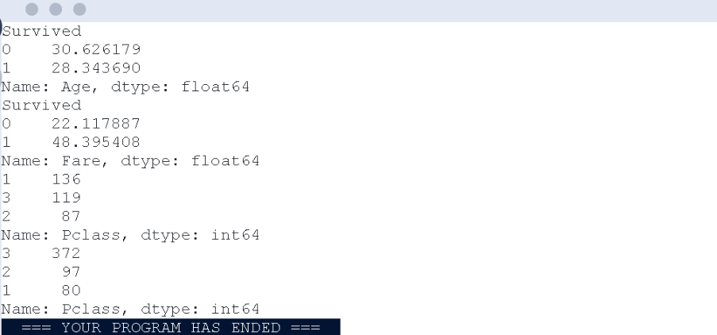

# 7. Get the average age by survival status
print(data.groupby('Survived')['Age'].mean())
# 8. Get the average fare by survival status
print(data.groupby('Survived')['Fare'].mean())
# 9. Get the number of survivors by class
print(data[data['Survived'] == 1] ['Pclass'].value_counts())
# 10. Get the number of non-survivors by class
print(data[data['Survived'] == 0] ['Pclass'].value_counts())
OUTPUT:

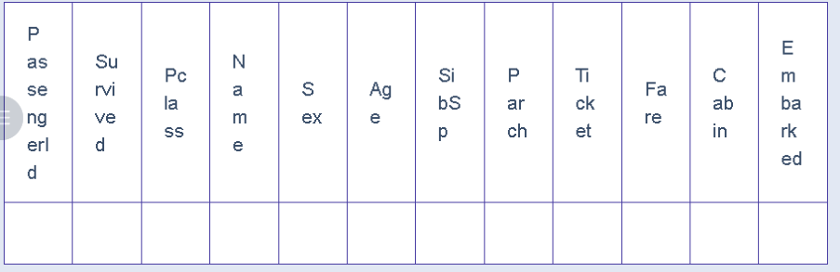

You are provided with the Titanic dataset containing information about
passengers on the Titanic. Your task is to write Python code to answer the
following questions based on the dataset.
1. Get the number of survivors by gender (Sex).
2. Get the number of non-survivors by gender (Sex).
3. Get the number of survivors by embarkation location (Embarked_S).
4. Get the number of non-survivors by embarkation location (Embarked_S).
5. Calculate the percentage of children (Age < 18) who survived.
6. Calculate the percentage of adults (Age >= 18) who survived.
7. Get the median age of survivors.
8. Get the median age of non-survivors.
9. Get the median fare of survivors.
10.Get the median fare of non-survivors.
The Titanic dataset contains columns as shown below,
CODE:

import pandas as pd
import numpy as np
# Load the Titanic dataset
data = pd.read_csv('Titanic-Dataset.csv')
data = pd.get_dummies(data, columns=['Embarked'], drop_first=True)
# 1. Get the number of survivors by gender
print(data[data['Survived'] == 1]['Sex'].value_counts())
# 2. Get the number of non-survivors by gender
print(data[data['Survived'] == 0]['Sex'].value_counts())
# 3. Get the number of survivors by embarked location
print(data[data['Survived'] == 1]['Embarked_S'].value_counts())
# 4. Get the number of non-survivors by embarked location
print(data[data['Survived'] == 0]['Embarked_S'].value_counts())
# 5. Calculate the percentage of children (Age < 18) who survived
children = data[data['Age'] < 18]
print(children['Survived'].mean())
# 6. Calculate the percentage of adults (Age >= 18) who survived
adults = data[data['Age'] >= 18]
print(adults['Survived'].mean())

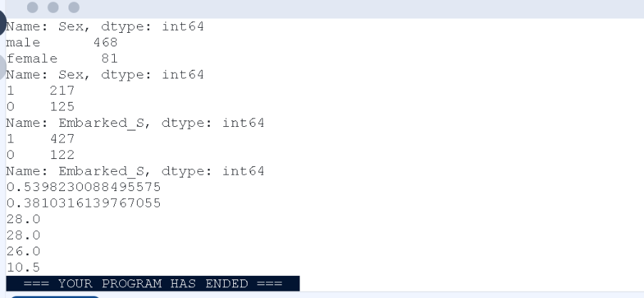

# 7. Get the median age of survivors
print(data[data['Survived'] == 1]['Age'].median())
# 8. Get the median age of non-survivors
print(data[data['Survived'] == 0]['Age'].median())
# 9. Get the median fare of survivors
print(data[data['Survived'] == 1]['Fare'].median())
# 10. Get the median fare of non-survivors
print(data[data['Survived'] == 0]['Fare'].median())
OUTPUT:

